Teach Base 10 and Binary System Software Guide

1) To create an entity to hold user input value from 0 – 9:

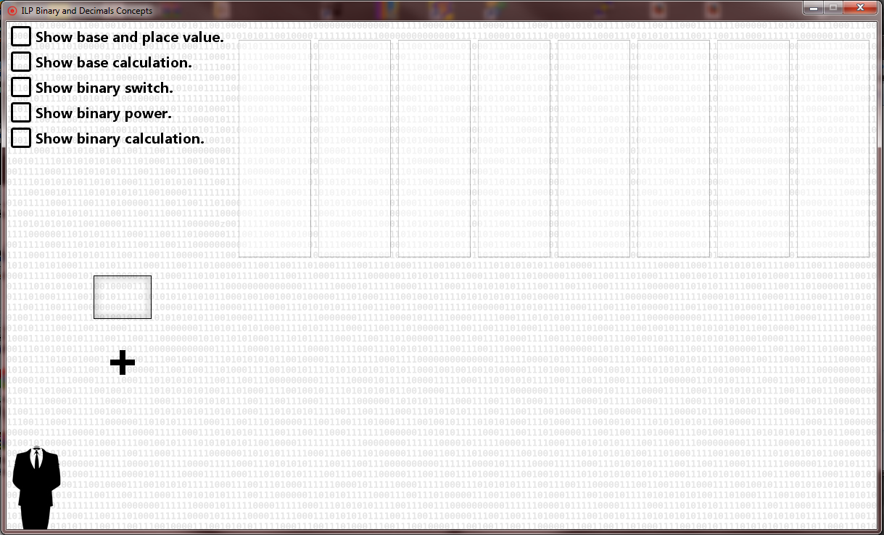

Left click on this input box icon and hold the left mouse button.

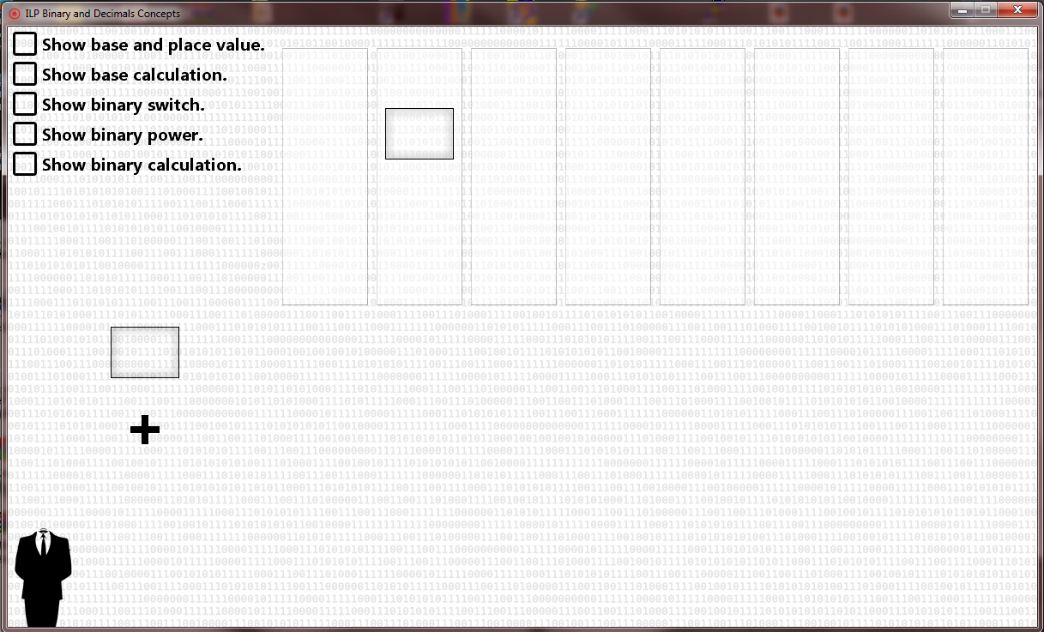

Drag and drop into any of the 8 slots, each slot represents a place value.

2) The options are self-explanatory.

3) To input value from 0 – 9.

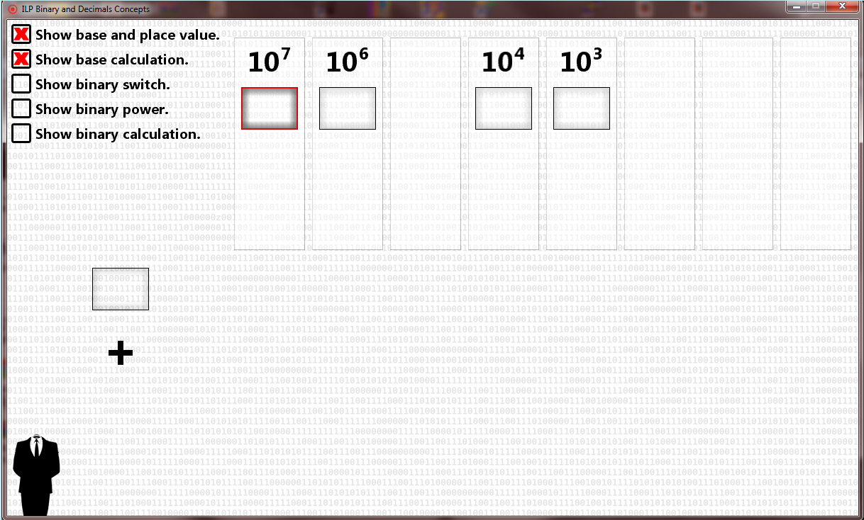

Click within the input box and either type in a number or use the mouse wheel to cycle through the digits.

4) To delete an entity. Press and hold the letter ‘D’ and left click on any entity.

5) Binary switch has to be selected in order to turn switches on and off.

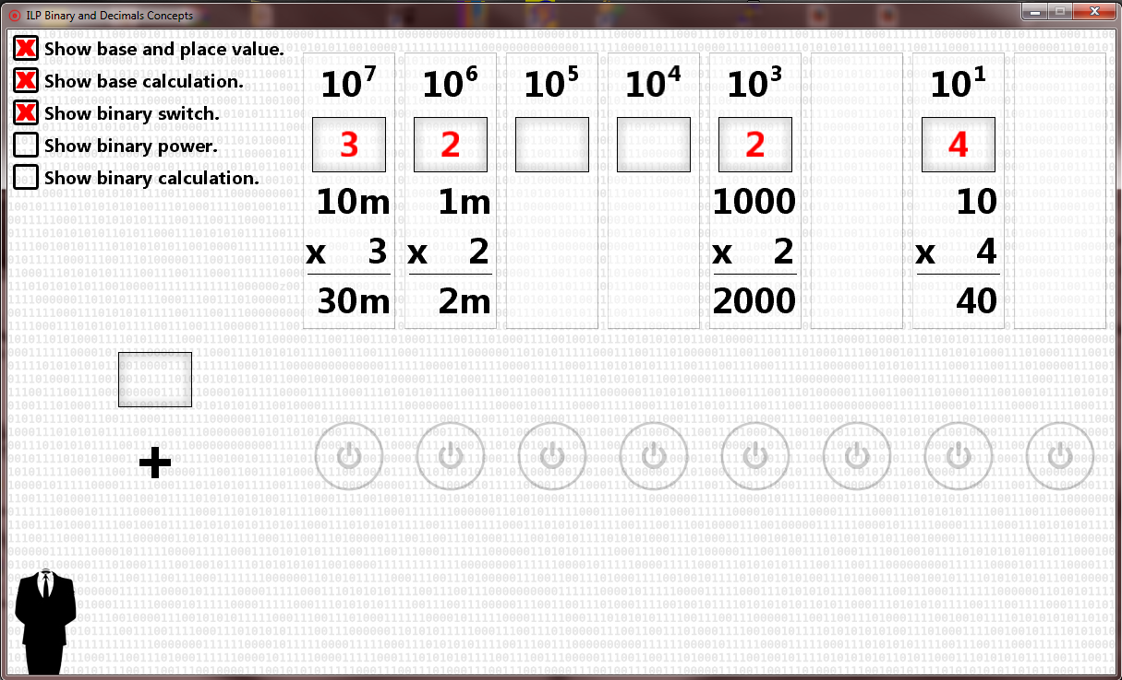

6) You can turn the switch on/off by either clicking with the mouse (left button) or using the num pad and/or the digits. You can simultaneously press any combination of the digits.

7) Turn all switch OFF: press ‘O’ + ‘F’ (at the same time)

8) Turn all switch ON: press ‘O’ + ‘N’ (at the same time)

9) To show the cumulative results of the base 10 and binary sequences click on the “+” (plus) icon. Cumulative results are in decimals.

